**CLIMATE TRACK SMART USING BLOCKCHAIN**

|  |  |
| --- | --- |
| Date | 29.10.2023 |
| Team ID | NM2023TMID03935 |
| Project Name | Climate Track Smart Using Blockchain |
| Maximum marks | 4 Marks |

#### Solution Architecture:

Solution architecture is a complex process – with many sub-processes – that bridges the gap between business problems and technology solutions. Its goals are to:

• Find the best tech solution to solve existing business problems.

• Describe the structure, characteristics, behaviour, and other aspects of the software

to project stakeholders.

• Define features, development phases, and solution requirements.

• Provide specifications according to which the solution is defined, managed, and

delivered.

**Example - Solution Architecture Diagram**

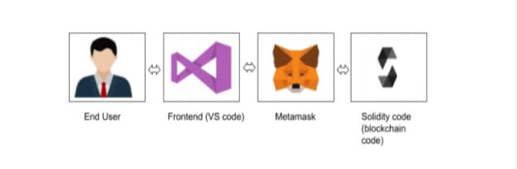

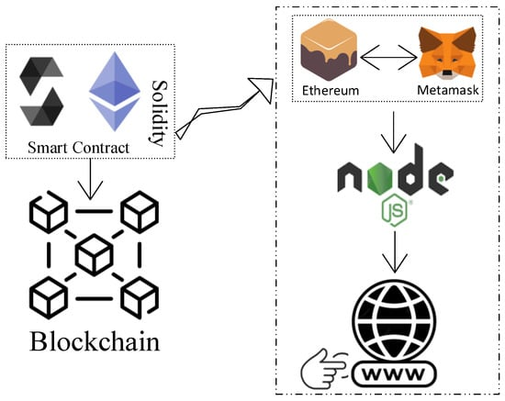

**Figure 1: Architecture and data flow of CLIMATE TRACK SMART System**